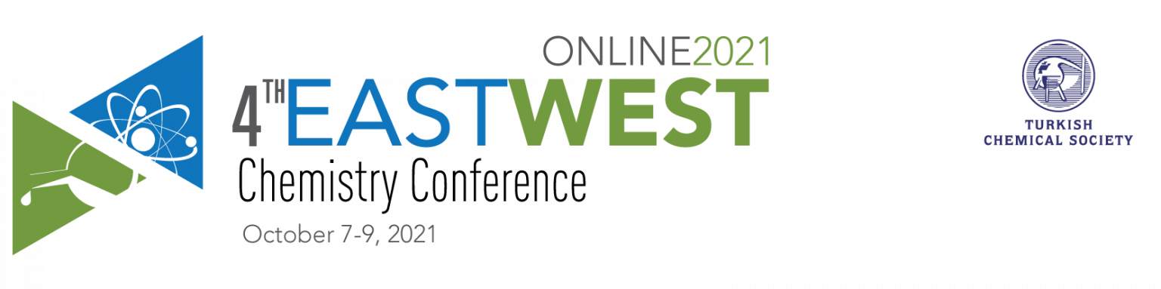Some quick tips and guidelines for the participants

We would like to thank you once again for your participation to the 4th EastWest Chemistry Conference on 7-9 October. We would like to give you the information about the congress (check also our updates on the conference site).

- The congress web page will be provided by the link to the special online platform and registered participants will have an online acess to all activities including E-POSTER sections and many more.
- There will be scheduled slots for all presentations during the virtual congress.
- There will be a chat function, as well as a live Q&A, for all sessions at specified times.
- We will kindly ask you to be present during the scheduled time to ensure interaction with the audience.
- The connections of our Speakers/Chairmans who will attend the meeting online will be made through the Zoom software. The required session information for the Zoom connection will be sent to you.
- The sessions will be run with pre-recorded video presentations opportunity. Therefore, we will kindly ask you to provide a video of your speech and presentation 1 weeks (30 September ) prior to the event taking place. Let us know immediately if you planned this option. You can send recorded videos directly to us to Events@brosgroup.net
- The congress web page will have a section called the Interactive E-Poster section on special online platform and all posters uploaded in JPEG format will be located there (see rules of poster preparation in the separate file). All participants will be able to see these posters and post comments/questions including the visitors of the National Chemistry Congress of the Turkish Chemical Society.
- The information about the structure of the sessions and Program is expected close to the next Monday.

